As it was required, the website provides opportunity for the following actions:

* Create an account
* Login
* Buy a ticket
* Add credit (top-up balance)
* Reserve camping spot
* Leave a review
* Logout

It is also possible to get information from the website pages: about event, reviews. For the logged in user it’s also possible to see information about balance/ticket number.

1. Create an account

Creating the account is possible in two ways. First one is to click “Buy a ticket” button on the Home page. 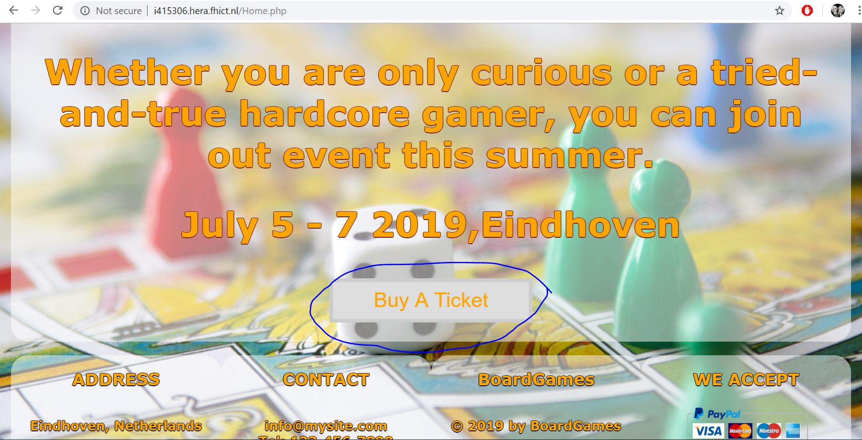

Second one is to click “Log in”

And click “Register” under the log in form.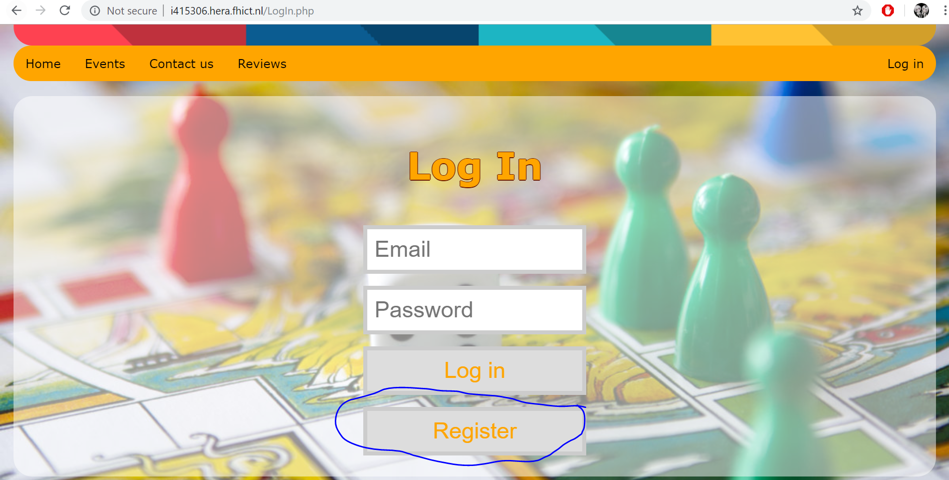

These two ways will lead you to the same registration page that is shown below. On this page you need to provide all the data and press “Register” button.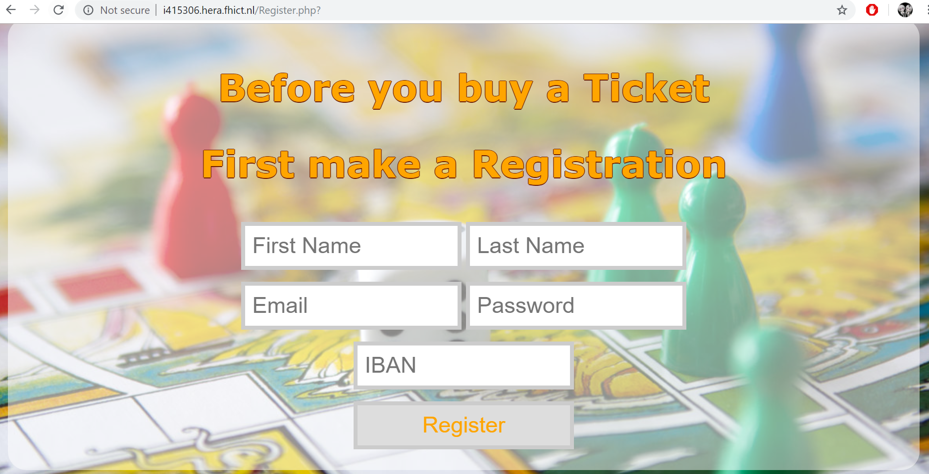

After providing the data and pressing register, you will be redirected to “Log In” page where you can log in with the details you submitted.  
After log in you will be redirected to home page, from which you can access